**Cloud Lab Set up**

**Introduction:**

We will use Google Cloud Platform to perform and execute our tasks throughout the course. Please feel free to watch lesson **1.8 Lab – Cloud Setup** in **Lesson – 1 – DevOps Overview and its Components** video available under SYLLABUS Section.

In this lab, you will sign up for Google Cloud free trail which demands credit card or a debit card to register for free trail and to confirm your identity. Please note that it will debit $1 for validation process which will be refunded within 24 hours.

**The free trail provides you:**

* $300 credit for resource utilization for next 60 days.
* You’ll not be billed - Your credit card is not charged during or after your free trial unless you upgrade to a paid account.

**To complete this lab, you need:**

* Internet access
* Access to a supported Internet browser
* A credit card or debit card to register for the free trial

**The following browsers are known to work:**

* The latest version of Google Chrome, Firefox, or Microsoft Edge
* Microsoft Internet Explorer 11+
* Safari 8+ (Safari private mode is not supported)

**DevOps Lab setup – 1.1 – Cloud lab set up.**

**Step -1:** Open the free trail registration page: <https://console.cloud.google.com/freetrial>

**Step -2:** If you do not have a Gmail account, follow the steps to create one. Otherwise, use your existing Gmail and proceed to the next step. (**Note:** The email ID should not have used before with GCP – Google Cloud Platform).

**Step-3:** Complete the registration form. Read and agree to the terms and conditions of the service.

**Step-4:** Click **Accept and Start the free trail.**

**Step-5:** Click on the three horizontal bars at the left-hand side of the blue bar near the top of the browser window. This will cause a tray to slide out from the left. In this tray, click on *Billing*. Next, refresh the browser window. This action will reveal a blue button in the upper right hand corner with the name "UPGRADE". *Click on the UPGRADE button* and confirm in the dialog box.

**Note: Things you should know after upgrading your account.**

1. You’ll not be billed until you complete $300 of free credits.
2. You’ll be billed only if you complete $300 and would like to continue utilizing the services.
3. Upgrading your account will help you utilize resources to the maximum level without any additional restrictions. It is recommended to upgrade the account.
4. Do not worry, $300 free credits are sufficient to complete the training and the work on the projects.

**Creating the DevOps Project: (Project Name: DevOps)**

**Step -1:** Go to [https://console.cloud.google.com](https://console.cloud.google.com/)  and click *SELECT A PROJECT > NEW PROJECT*. As shown in the example screenshot.

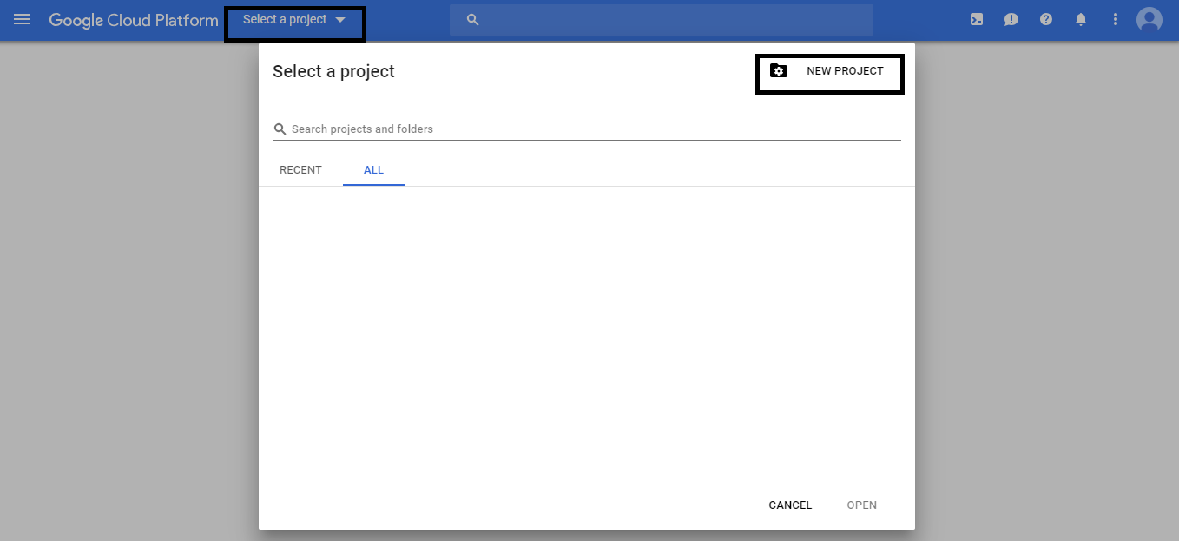

Step-2: Change the name from **my project xxxxx** to **DevOps xxxxx** (Do not change the number). If you have configured multiple billings accounts, select your preferred account as **BILLING ACCOUNT**. Click **CREATE** to create your project as shown in the example screenshot.

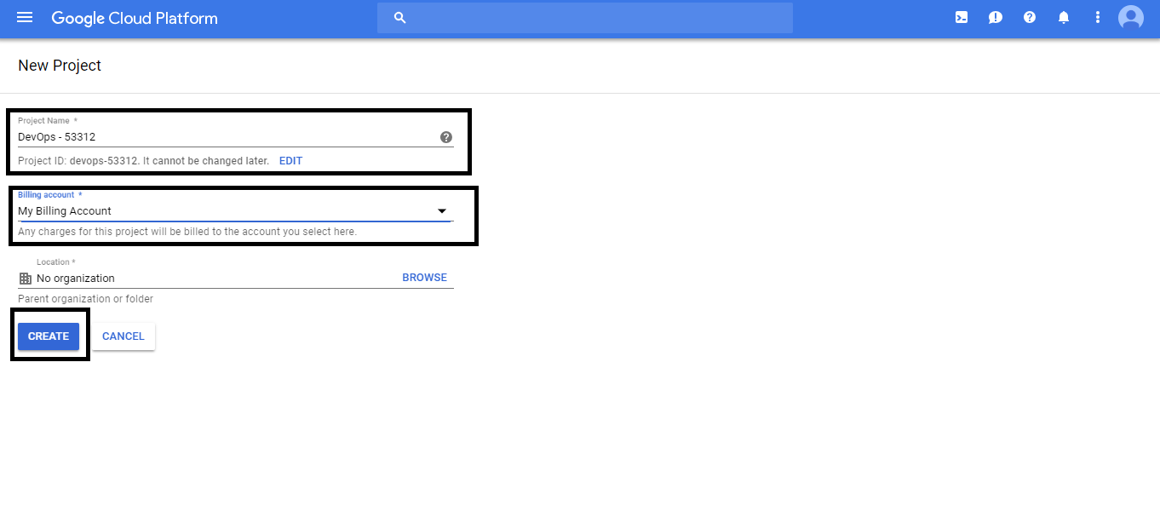

**Create your Virtual Computer:**

Step-1: Click on the three horizontal bars at the left-hand side of the blue bar near the top of the browser window. *Select Compute Engine*. Be patient and wait until Google initializes this area of the Google Cloud Platform for you as shown in the below screenshot.

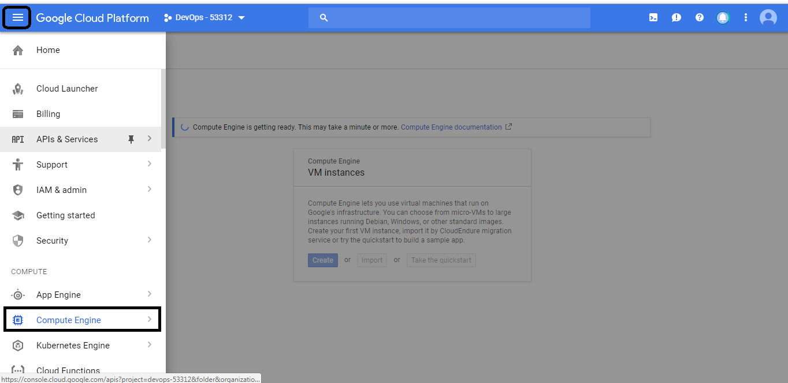

Step-2: *Click on the first icon to the right of the search area in the blue bar*. If you hover over this icon, you will see the hint “*Activate Google Cloud Shell*.” *Click on this icon* and notice that a terminal is opened at the bottom of the browser window as shown in the example screenshot.

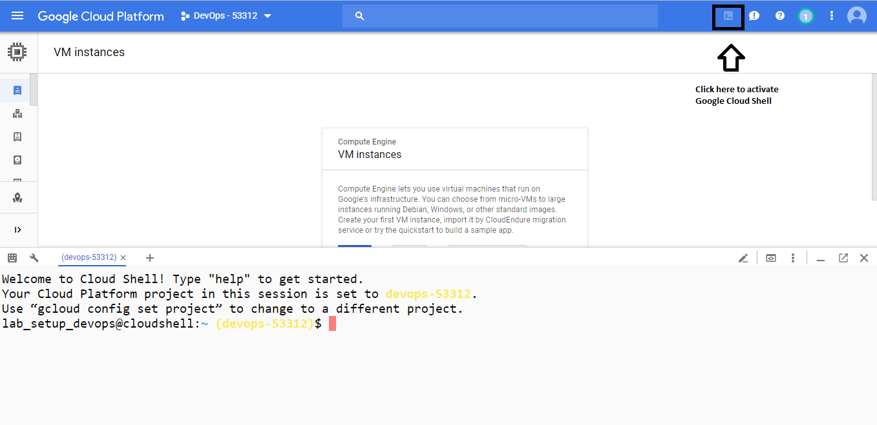

Step-3: Simplilearn has a DevOps image which you need to copy to your bucket (It is a logical unit of storage). Hence you need to create a bucket. You need to create a unique identifier. For e.g. *Devops(Project_Name)-xyz-dateorname*

Note: We will use **gsutil** ( [gsutil:](https://cloud.google.com/storage/docs/gsutil) A python application that lets you access Cloud Storage from the command line). A **mb** is used to make buckets.

***gsutil mb gs://devops-rak-20180612*** – this is an example name used for the project.

Check the available files in the bucket you created with the help of **ls** command as shown below:

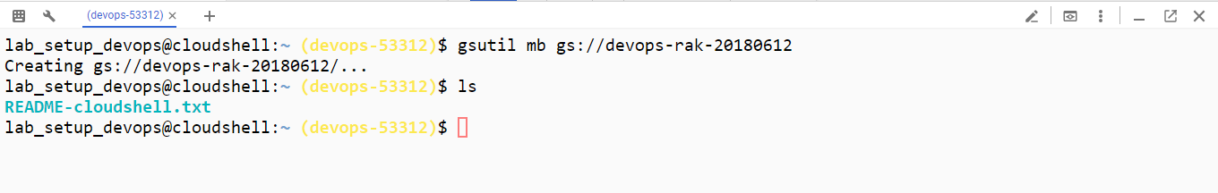

Step-4: Now you need to copy files from a bucket in another project to the new bucket. Type the following.

*gsutil cp gs://simplilearn-devops-image/* gs://devops-rak-20180612*

You should be able to copy to your bucket from Simplilearn’s Devops bucket. You can explore more with **gsutil ls yourbucketname** command to check the copied files.

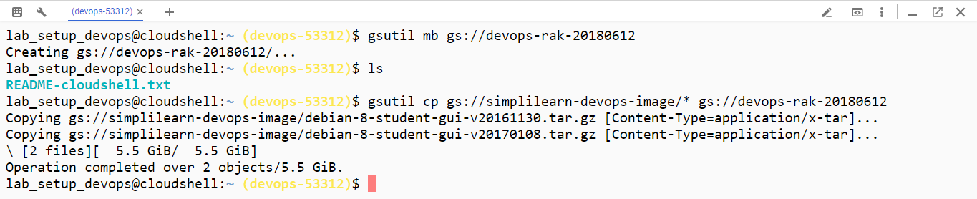

Close the shell with **exit** command.

**Create your own / custom image:**

Select *Images* from the left column. A list of images will appear.

You need to create an image to create a computer. Select *CREATE IMAGE* at the top of the page as highlighted in the below screenshot.

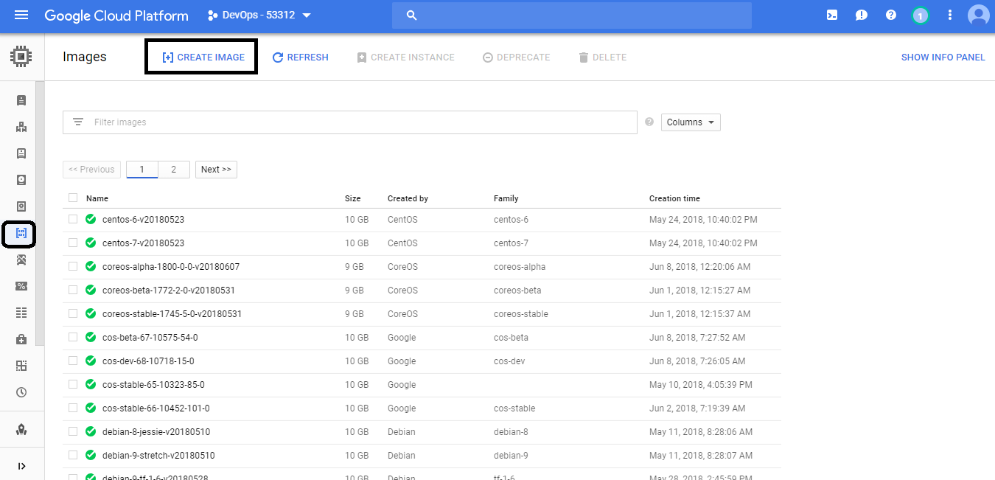

Enter Name student-image.  
Leave Family and Description blank.  
Change Source to *Cloud Storage file*  
Hit *Browse* and you will see your bucket. Hit the arrow to the right of the bucket, and you will see the two files. Select the latest one ending 20170108.tar.gz.  
Hit *Select*.

Now, create an image from the file by hitting *Create*. [Please check the screenshot]

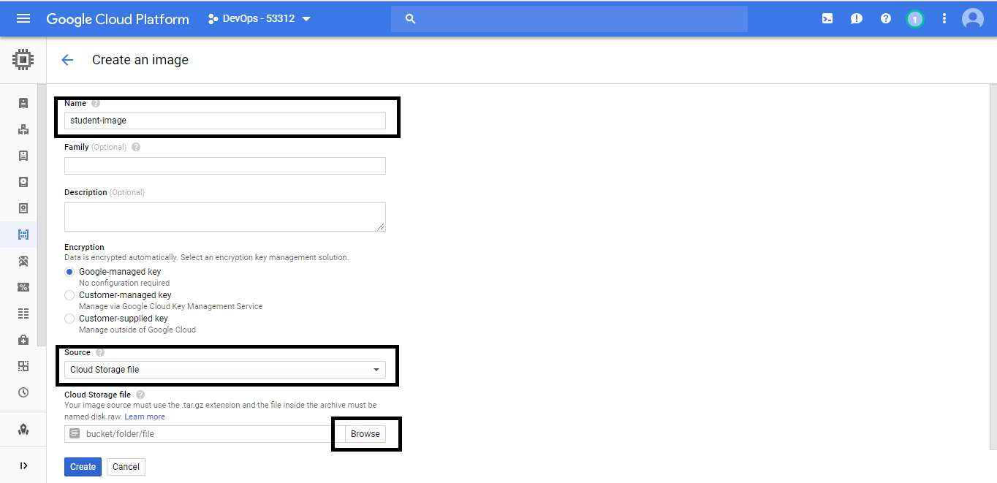

**It’s time create a computer from the image you created.**

Select *VM Instances* from the left-hand column. Select *Create Instance*.

Give it the Name lab  
Select a Zone near your location.  
See that it tells you the Effective hourly rate and the estimated monthly cost. This cost will barely impact your $300 credit.

Choose how many CPUs and how much memory you want. The default is sufficient. Note that more CPUs and more memory increase the cost.[Please check the screenshot]

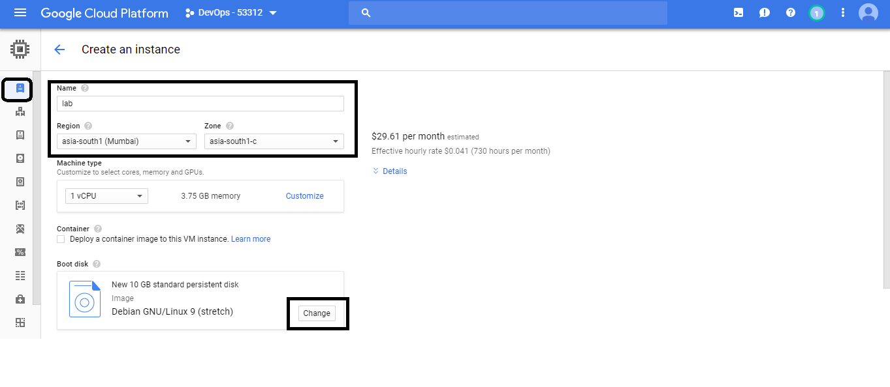

We need to specify a boot disk. Select *Change*. You will see a list of OS images. Select the *Custom images* tab.

You need to define the *Boot disk type*. Select *SSD persistent disk* and give it a *Size* of 200. Select *Select*.[Please check the screenshot]

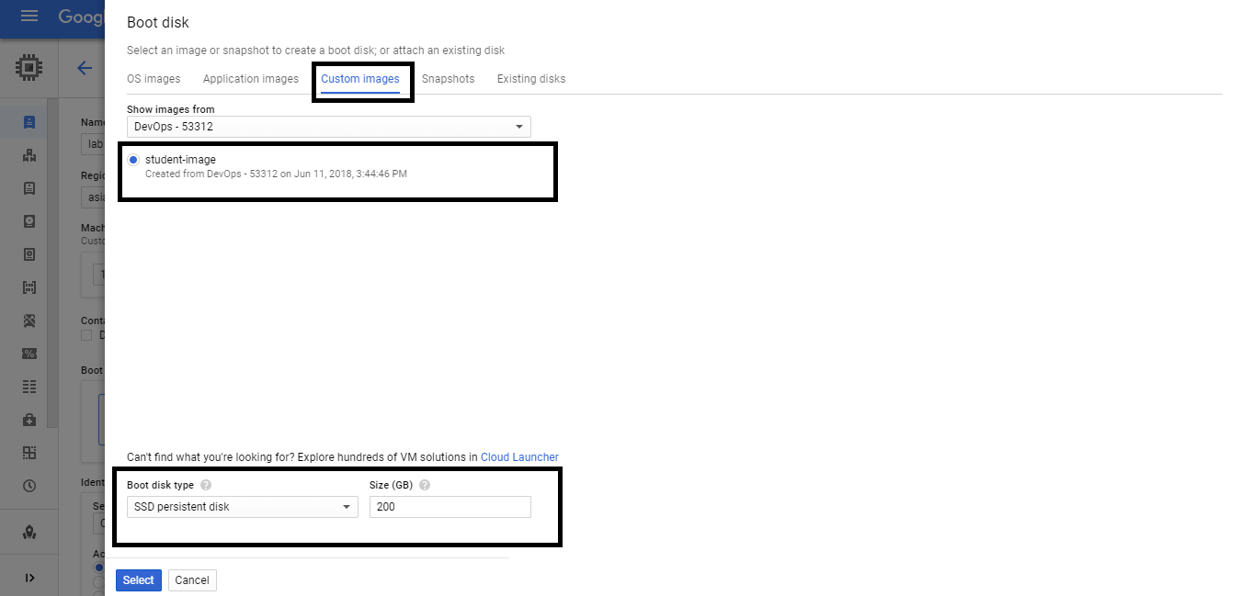

Now, create it by hitting *Create* at the bottom of the screen. It will take a few minutes.

You should see the VM Instance. Note that it is running.

**Work with SSH:**

*Click the SSH button* at the right-hand side of the line of information about your new lab computer. This will open a new browser window with a terminal connection.

**Change the host name to student:** Find the icon that looks like a gear in the upper right-hand corner of this terminal browser window and select *Change Linux User Name*. Enter *student* and *click Change*. Now, notice the prompt that says "student@lab:~$" [Please check the below screenshot]

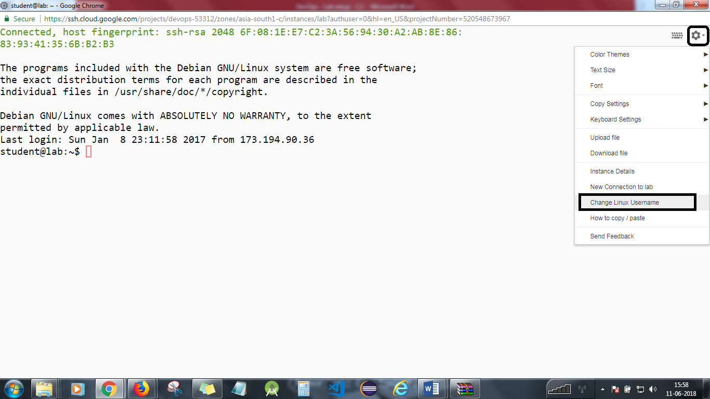

You now have a working computer for conducting all class work for the DevOps Practitioner course.

See what is installed. Explore the machine.  
*ls -l*

**Exercise -1: Let’s install maven.**

We will now install Maven. You need to be root, so execute the below command.

*sudo apt-get update  
sudo apt-get install maven*You will see a long list of dependencies.  
Enter *Y* to accept them.

Maven will be installed.

Check the versions of Java and Maven that are installed.  
*java -version  
mvn -v*

Close the SSH window.  
*exit*

You will need to stop the lab computer at the end of each day to prevent it from accumulating costs during the evening and night.

From the Web UI, you can navigate to the Compute Engine section and select your lab computer. When it is selected, click on the icon representing the "Stop" operation as shown below:

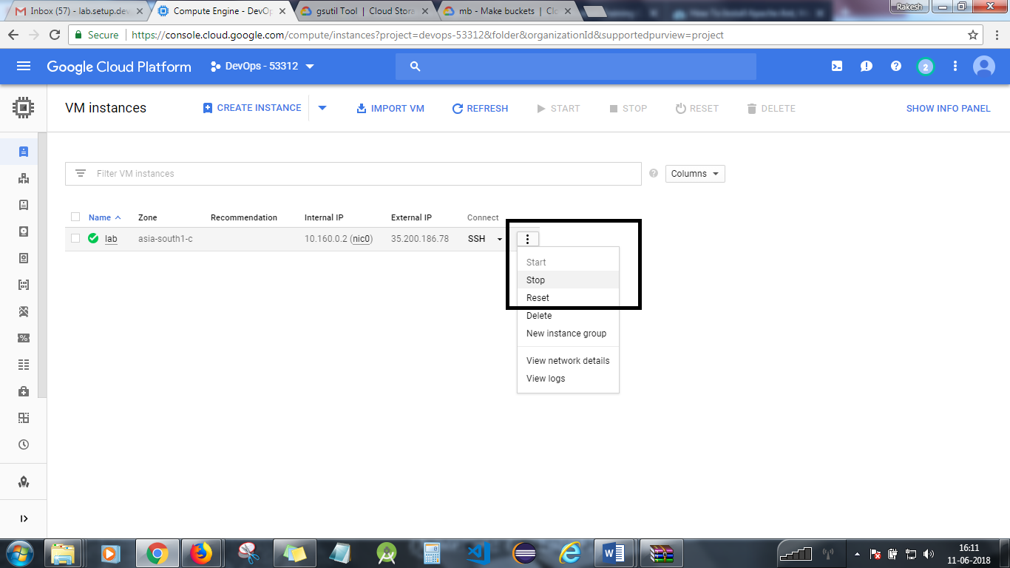

Watch recording to see how to create a VM on Amazon AWS and MS Azure.